

**EE4305 Fuzzy/Neural Systems for Intelligent Robots**

**Assignment 2**

**Lim Yu Guang**

**A0172618B**

**Assess water quality of rivers using fuzzy logic technology**

**Abstract**

This technical paper reviews on fuzzy logic application in assessing water quality of rivers. The problems faced with non-fuzzy approach was stated and fuzzy logic has managed to address it. Specific description of the fuzzy logic application was discussed, with focus on the input(s) and output(s) of the fuzzy inference system, membership functions and fuzzy rules used. Advantages and disadvantages of the fuzzy inference system used in this application were also evaluated. Lastly, suggestion for improvements were examined.

**Introduction**

Rivers have always play key ecological, economic, and social importance in the history of human civilization [1, 2]. Rivers provide rich supply of food and water for sustenance. Apart from providing extensive amount of fresh water, which can be used for drinking and bathing, rivers also offer a large amount of fishes and other edible aquatic life. However, rivers are also a convenient way for disposing domestic and industrial wastewater discharges, especially in the less developed nation [1]. This eventually leads to water pollution in rivers and it degrades the water quality in those rivers. Poor water quality in river can result in dire consequences, which includes waterborne illness after drinking the contaminated water and damage to the marine ecosystem [3]. Thus, frequent evaluation of surface water quality in rivers is necessary to ensure the rivers are within the healthy and acceptable range.

To resolve this problem, state agencies and environmental experts created various water quality indices to measure and assess the water quality of rivers. Most of these indices used in different parts of the world are derived from Water Quality Index (WQI), developed by the U.S. National Sanitation Foundation [4]. WQI is a single number used for overall description of water quality, calculated from 9 key input parameters which affects water quality. The 9 water quality parameters are dissolved oxygen, fecal coliforms, biochemical oxygen demand, pH level, temperature change, phosphates, nitrates, turbidity, and total solids [4, 5]. In addition, each of these water quality parameters are assigned a weight factor according to their importance in the rivers and the WQI is calculated based on a weighted sum of these input parameters.

While the formulation of WQI is elementary, it has serious limitations. WQI is unable to deal with uncertainty, and subjectivity in the complex environmental world, where different rivers face different kinds of water pollution [4]. The application of fuzzy logic technology in this problem is highly relevant and suitable. The fuzzy reasoning in fuzzy logic helps to deal with uncertain and imprecise input data. The fuzzy logic also encompasses advanced knowledge from environmental experts to resolve this complex problem. The implementation of fuzzy logic to assess water quality of rivers will be discussed in greater details in the next segment.

**Methodology**

Fig. 1. Basic architecture of fuzzy inference system used to assess water quality in rivers [4]

To assess water quality of rivers using fuzzy logic, a fuzzy inference system needs be designed and implemented. Fuzzy inference system is the process of creating the relationship between given inputs (water quality indicators) and a single output (water quality status) using fuzzy logic. As shown in Figure 1, a set of if-then rules known as, fuzzy rules, are used to evaluate the given inputs. Then, the results of these rules are combined and a single output value indicating the water quality is obtained. Based on the water quality score obtained in the previous step, water quality of the river can be determined in linguistic form. This segment will further discuss the input(s) and output(s) of the fuzzy inference system, the membership functions and fuzzy rules used to assess water quality of rivers. An example to demonstrate the computation of the fuzzy inference system will also be discussed.

1. **Inputs and Outputs of the Fuzzy Inference System**

|  |  |
| --- | --- |
| **Name and their abbreviations** | **Units** |
| **Inputs** | |
| Dissolved Oxygen (DO) | % |
| Fecal Coliforms (FC) | CFU/100 mL |
| Biochemical Oxygen Demand (BOD5) | mg/L |
| Temperature (T) | °C |
| Phosphates (PO4) | mg/L |
| Nitrates (NO3) | mg/L |
| Turbidity (TUR) | NTU |
| Total Solids (TS) | mg/L |
| Hydrogen Potential (pH) | - |
| **Output** | |
| Water Quality Status | - |

Table 1. Inputs and output of the fuzzy inference system

The input parameters used in the fuzzy inference system is the same as the water quality indicators used in WQI calculation. This is because the water quality indicators used in WQI are main indicators endorsed by environmental experts, which effectively reflect the physicochemical and biological water quality status of rivers [6]. The outputs of the fuzzy inference system are the water quality status – poor, average, or good. The inputs and output of the fuzzy inference system can be observed and summarized in Table 1.

1. **Membership Functions**

Before the fuzzy rules can be applied on the input water quality indicators, membership function must be defined for each input parameter. The membership function gives the numerical value of the input parameter a membership grade, which describes the property of the input parameter [7]. The process discussed so far is part of the fuzzification process of the fuzzy interference system.

“Low”, “Medium” and “High” fuzzy sets are used for the inputs, whereas, “Poor”, “Average” and “Good” fuzzy sets are used for the outputs. In addition, the membership function used to define these fuzzy sets is the trapezoidal membership function [4]. The trapezoidal membership function is selected for convenience in construction and, linear fuzzy sets are simpler to deal with during the defuzzification process and still provide great results [8, 9].

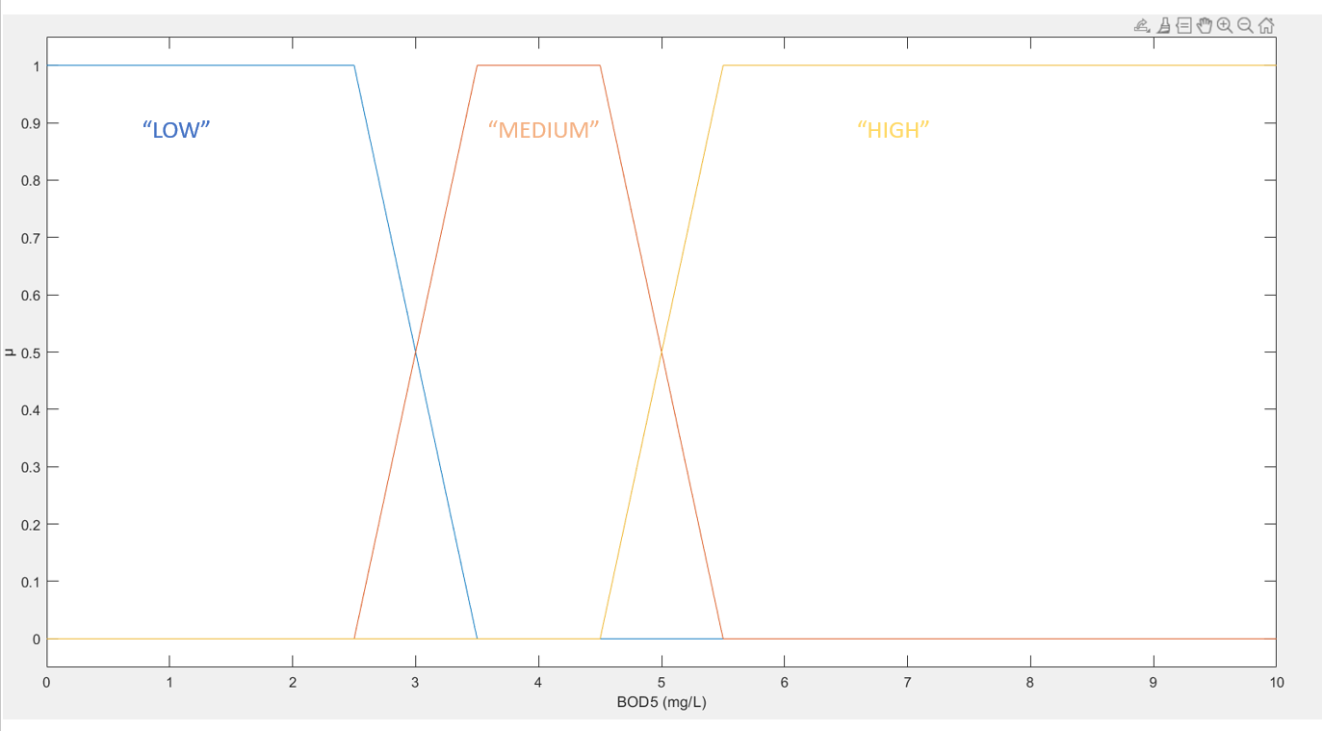

Fig. 2. Membership functions of Biochemical Oxygen Demand (BOD5)

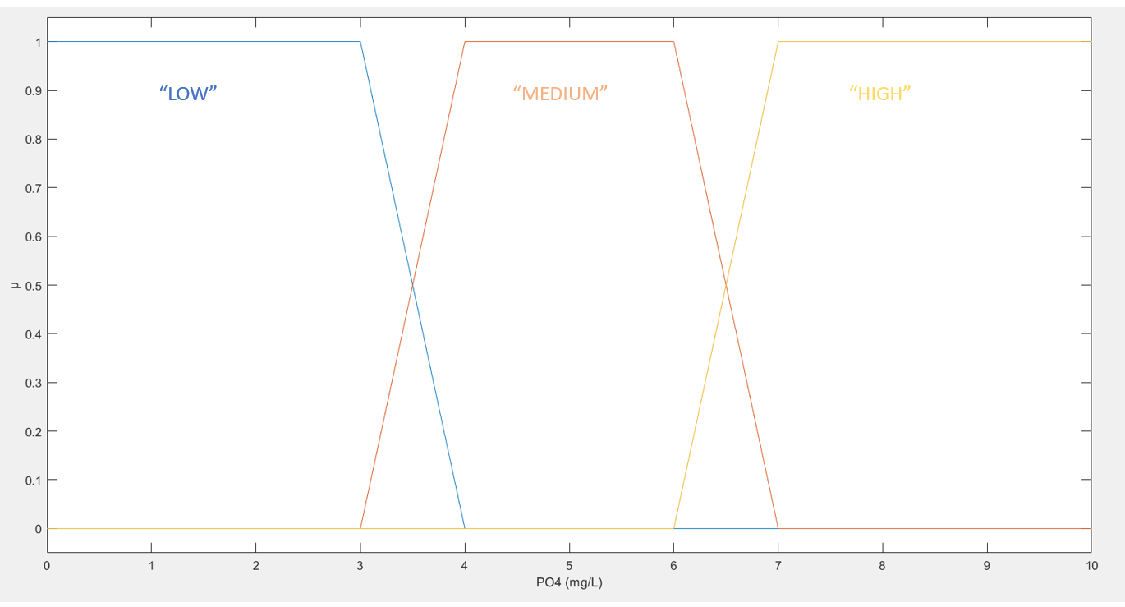

Fig. 3. Membership functions of Phosphates (PO4)

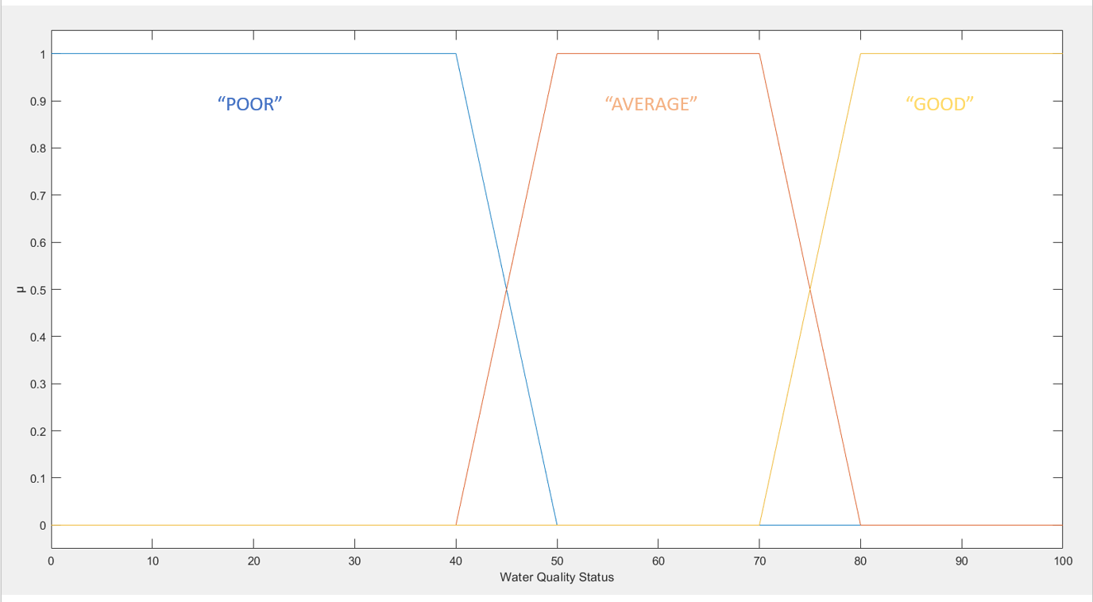

Fig. 4. Membership functions of Water Quality Status

Figure 2, 3 and 4 illustrates the examples of membership functions for the inputs and output of the fuzzy inference system.

1. **Fuzzy Rules**

Fuzzy rules are essentially if-then rules. The if-then rule consists of the ‘if’ portion called antecedent, and ‘then’ portion called the consequent. The fuzzy rules are expressed in the following form [10]:

IF X is x, THEN Z is z

IF Y is y, THEN Z is z

where x, y, and z are linguistic values defined by fuzzy sets in universe of discourse X, Y, and Z, respectively.

In addition, fuzzy set operators can be used to express the relationships between the fuzzy sets of the inputs [10]. The common fuzzy set operations used are intersection (AND), union (OR) and complement (NOT). When these fuzzy set operations are used in the fuzzy rules, it is expressed in the following form:

IF X is x AND Y is y, THEN Z is z

IF X is x OR Y is y, THEN Z is z

where x, y, and z are linguistic values defined by fuzzy sets in universe of discourse X, Y, and Z, respectively.

|  |  |  |
| --- | --- | --- |
| IF-THEN rules | | |
| Rule Number | IF | THEN |
| 1 | IF BOD5 is “low” AND DO is “high” | THEN Water Quality Status is “good” |
| 2 | IF BOD5 is “medium” AND DO is “medium” | THEN Water Quality Status is “average” |
| 3 | IF BOD5 is “high” AND DO is “low” | THEN Water Quality Status is “poor” |
| 4 | IF T is “high” AND NO3 is “high” | THEN Water Quality Status is “poor” |
| 5 | IF FC is “medium” AND NO3 is “high” | THEN Water Quality Status is “poor” |
| 6 | IF TUR is “high” AND pH is “high” | THEN Water Quality Status is “poor” |
| 7 | IF NO is “low” AND BOD5 is “low” | THEN Water Quality Status is “good” |
| 8 | IF TS is “low” AND PO4 is “medium” AND NO3 is “medium” | THEN Water Quality Status is “average” |
| 9 | IF FC is “low” OR T is “low” | THEN Water Quality Status is “good” |
| 10 | IF TUR is “low” AND pH is “medium” AND T is “medium” | THEN Water Quality Status is “good” |

Table 2. Sample of fuzzy rules used in the fuzzy inference system

Table 2 shows the sample of fuzzy rules used in the fuzzy inference system to determine whether the water quality status is “poor”, “average” or “good” in quality. The antecedent consists of conditions made up from the inputs of the fuzzy inference system shown in Table 1 and the consequent is the evaluation of the results based on expert knowledge.

1. **Example of computations in the Fuzzy Inference System**

This section will demonstrate an example of computations in the fuzzy inference system. For simplicity of illustration, assume only Biochemical Oxygen Demand (BOD5) and Phosphates (PO4) are measured from the river and only the first 3 rules in Table 2 are applied. The measured values for BOD5 and PO4 are 3.2mg/L and 6.6mg/L, respectively. Based on the membership functions of BOD5 defined in Figure 2, a value of 3.2mg/L for BOD5 is associated with the “LOW” and “MEDIUM” fuzzy sets, having membership grade of approximately 0.2 and 0.8, respectively. Moreover, using the membership functions of PO4 defined in Figure 3, a value of 6.6mg/L for PO4 is associated with the “HIGH” and “MEDIUM” fuzzy sets, having membership grade of approximately 0.5 and 0.5, respectively.

Fig. 5. Fuzzy inference diagram for assessing water quality of rivers based on 2 water quality indicators and 3 rules applied

Figure 5 shows a fuzzy inference diagram based on 2 water quality indicators and 3 rules applied. After applying the fuzzy operator and implication operator on each rule, this results in a truncated output fuzzy set based on the firing strength of each rule. Aggregation operator is used to join all these truncated output fuzzy sets into a single combined output membership function. Lastly, the aggregated membership function needs to be reduced to a crisp value and the defuzzification method using center of area is applied to obtain the water quality score. This water quality score will then be mapped towards a water quality status.

**Advantages and Disadvantages**

This segment will discuss both the advantages and disadvantages of applying fuzzy logic in assessing water quality of rivers.

The most notable advantage of the applying the fuzzy logic in assessing water quality of rivers is that the fuzzy logic can deal with imprecise data from the input parameters (water quality indicators). The non-fuzzy approach of assessing water quality can only take in a single value parameter from each water quality indicators and calculate the final water quality score. In practical, there are both qualitative and quantitative data of water quality indicators, and only fuzzy logic can evaluate qualitative water quality indicators. Moreover, there is always a range of values measured from the water quality indicators. The fuzzy logic takes these issues into account and factor in the fuzzy nature of measurement for evaluation of the water quality in rivers [4, 10].

Another advantage is the fuzzy inference system is easily understood and simple to use. The fuzzy inference system is built based on words and reasoning process. No equations were used to represent the problem which is characterized to be highly non-linear and difficult to model accurately in nature. This is highly beneficial for individuals who have no mathematical knowledge, where they can assess the water quality of rivers without mathematical understanding of water quality index [4, 9, 11].

Although the advantages of using fuzzy logic in assessing water quality of rivers appears promising, there are disadvantages of using fuzzy logic in this application. The non-fuzzy approach of assessing water quality in rivers factored in the order of importance of the water quality indicators used. The non-fuzzy approach, WQI, takes the weighted sum of the water quality indicators for calculation. In contrast, the fuzzy logic does not consider the weighted importance of each water quality indicators. The fuzzy logic might suffer inaccurate results because all the input water quality indicators are given equal weightage [9, 11]. In practical, certain pollutants might be more significant in the rivers, and this information will not be represented and captured by the fuzzy inference system. Hence, delivering an inaccurate water quality status.

Another disadvantage of using fuzzy logic in assessing water quality of rivers is the process of generating the fuzzy rules and membership functions. The process is time consuming and a difficult task. Unlike typical non-fuzzy approach, where measurements are taken for each input parameters and results are calculated based on weighted average, the fuzzy approach requires time and expert knowledge to formulate the set of fuzzy rules and membership functions before usage.

**Suggestions for improvement**

This segment will provide some recommendations of improvement on the fuzzy inference system used to assess water quality of rivers.

When there are many input parameters (water quality indicators) used in the fuzzy inference system, the parameters are usually correlated, and this makes an assessment unreasonable [12, 13]. There needs to be a way to remove or avoid such correlated parameters. Principal Component Analysis (PCA) is used in environ metrics for data compression and information extraction [14]. PCA can be applied to the input parameters of the fuzzy inference system to obtain independent principal components which avoids correlation of the parameters.

Furthermore, as mentioned earlier, the fuzzy logic does not consider the weightage of each water quality indicator during computation. An appropriate weight assignment to water quality indicators (input parameters) can applied to improve the quality of the fuzzy inference system. Analytic hierarchy process is a process that can be used to gauge the relative importance of each water quality indicators in the fuzzy inference system [4, 11].

**Conclusion**

This paper discussed the application of fuzzy logic in assessing water quality of rivers. The use of the fuzzy logic provides a way for evaluation of the water quality status similar to human reasoning, by gathering complex knowledge from experts. While the implementation of the fuzzy logic can be a difficult task, it still offers favorable results which are better than non-fuzzy approach. The prospects of fuzzy logic application are promising as its limitations can be easily addressed. With sufficient continued efforts and exploration of the fuzzy logic, application of fuzzy logic in daily life should become more prominent in the near future.

# References

|  |  |
| --- | --- |
| [1] | D. S. Singh, "Springer Link," 2018. [Online]. Available: https://link-springer-com.libproxy1.nus.edu.sg/book/10.1007%2F978-981-10-2984-4. [Accessed 1 April 2021]. |
| [2] | W. Y. Chen, "Environmental externalities of urban river pollution and restoration: A hedonic analysis in Guangzhou (China)," Science Direct, 2016. |
| [3] | M. Denchak, "Natural Resources Defense Council (NRDC)," 14 5 2018. [Online]. Available: https://www.nrdc.org/stories/water-pollution-everything-you-need-know#causes. [Accessed 1 April 2021]. |
| [4] | WilliamOcampo-Duque, NúriaFerré-Huguet, J. L.Domingo and MartaSchuhmacher, "Assessing water quality in rivers with fuzzy inference systems: A case study," Science Direct, 2006. |
| [5] | O. T. Dede, I. T. Telci and M. M. Aral, "The Use of Water Quality Index Models for the Evaluation of Surface Water Quality: A Case Study for Kirmir Basin, Ankara, Turkey," Springer Link, 2013. |
| [6] | WilliamOcampo-Duque, C. Osorio, C. Piamba, M. Schuhmacher and J. L. Domingo, "Water quality analysis in rivers with non-parametric probability distributions and fuzzy inference systems: Application to the Cauca River, Colombia," Science Direct, 2012. |
| [7] | R. Kumaravel, S. Dhanasekar and K. H. Kumar, "A fuzzy inference system-an estimation of the quality of river water in Tamil Nadu," AIP Conference Proceedings, 2019. |
| [8] | H. Yan, Z. Zou and H. Wang, "Adaptive neuro fuzzy inference system for classification of water quality status," Science Direct, 2010. |
| [9] | J. JuanCarbajal-Hernández, L. P.Sánchez-Fernández, J. A.Carrasco-Ochoa and J. FcoMartínez-Trinidad, "Immediate water quality assessment in shrimp culture using fuzzy inference systems," Science Direct, 2012. |
| [10] | H. Gharibi, M. H. Sowlat, A. H. Mahvi, H. Mahmoudzadeh, H. Arabalibeik, M. Keshavarz, N. Karimzadeh and G. Hassani, "Development of a dairy cattle drinking water quality index (DCWQI) based on fuzzy inference systems," Science Direct, 2012. |
| [11] | M. EsmeraldaVigueras-Velázquez, J. JuanCarbajal-Hernández, L. PastorSánchez-Fernández, J. LuisVázquez-Burgos and J. AntonioTello-Ballinas, "Weighted fuzzy inference system for water quality management of Chirostoma estor estor culture," Science Direct, 2020. |
| [12] | M. Sahu, S. S. Mahapatra, H. B. Sahu and R. K. Patel, "Prediction of Water Quality Index Using Neuro Fuzzy Inference System," Springer Link, 2011. |
| [13] | S.S.Mahapatra, S. KumarNanda and B.K.Panigrahy, "A Cascaded Fuzzy Inference System for Indian river water quality prediction," Science Direct, 2011. |
| [14] | C.Sârbu and H.F.Pop, "Principal component analysis versus fuzzy principal component analysis: A case study: the quality of danube water (1985–1996)," Science Direct, 2004. |